Simulation in R:

**Random Numbers**

1. **Rnorm**: generates normal random variables with a given mean and st dev (defaults to a mean of zero and a st dev of 1)
   1. Formatted as rnorm(n, mean = 0, sd = 1) where n is number of numbers to be generated
2. **Dnorm**: evaluates the normal probability density (with a given mean/st dev) at a point or vector of points
   1. Formatted as dnorm(x, mean =0, sd = 1, log = FALSE)
   2. Log = FALSE is because we can set it to evaluate on the log scale of the density if we desire
3. **Pnorm:** evualuates the cumulative distribution function for a normal Distribution
   1. Formatted as pnorm(q, mean = 0, sd = 1, lower.tail = TRUE, log.p = FALSE)
   2. If Φ is the cumulative distribution function for the Normal Distribution, then pnorm(q) = Φ(q) and qnorm(p) = Φ-1(p)
   3. Log.p = FALSE is because we can set it to evaluate on the log scale if we desire
   4. Lower.tail = the part that goes to the left (from, say the value x at the sd of -infinity to the value q specified). Setting to FALSE calculate from the value q to the value x at the standard deviation of +ininity
4. **Qnorm:** calculates the quantiles for the normal distribution.
   1. Formatted as qnorm(p, mean = 0, sd = 1, lower.tail = TRUE, log.p = FALSE)
   2. Log.p = FALSE is because we can set it to evaluate on the log scale if we desire
   3. Lower.tail = the part that goes to the left (from, say the value x at the sd of -infinity to the value p specified). Setting to FALSE calculate from the value p to the value x at the standard deviation of +ininity
5. **Rpois**: generates random Poisson variables at a given rate
   1. Nice because it can create random integer
6. **Distribution Functions**: have 4 functions associated with with
   1. Functions prefixed with a “d” stand for density functions
   2. Functions prefixed with an “r” create random numbers
   3. Functions prefixed with a “p” calculate the cumulative distribution function
      1. In other words, what is the probability that a number “p” is less than or equal to a given probability, given a mean and st dev
   4. Functions prefixed with an “q” calculate the quantile function - e.g. “qnorm,” “qpois”

**Example of Generating random numbers:**

* X <- rnorm(10) # gives 10 random normal variables with a mean of 0 and a st dev of 1
* Y <- rnorm(10, 20, 2) #gives 10 random normal variables with a mean of 20 and a st dev of 2
* summary(x) and summary(y) will give the min, max, median, and 1st and 3rd quantile

**Setting a seed**

1. You can set a seed in order to get the same “random” variables if you’re running a simulation that needs to be reproduced
   1. This implies the random variables are not “random,” but computationally they’re close enough.
   2. Command: **set.seed(1)**

X <- rnorm(5)

**Simulating a Linear Model**

1. **Generating Random numbers from a linear model**
   1. Example: $y= B_{0} + B_{1}x+ ε$ Where *B0* and *B1* are assigned random numbers and $ε$ is a vector containing rnorm(100,0,2). For this example, *B0* is set to 2 and the slope *B1*is set to 0.5. We’ll look at *x* over the standard normal distribution.
   2. This will give us a roughly linear set of data, as shown in the scatter plot

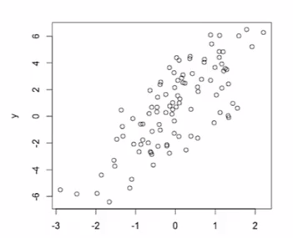

1. Generating Random Numbers using binary random variables (such as gender, treatment groups vs control, etc)
   1. Example: use $y= B_{0} + B_{1}x+ ε$, but set x’s range to be binomial random variables, such as $x=\text{rbinom}(100, 1, 0.5)$ (0.5 means there is an equal chance of 0’s or 1’s)
   2. This gives us data that is different  
      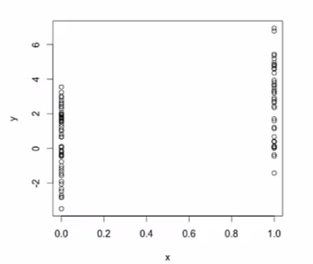
   3. Generating Random Numbers using a Generalized Linear model, such as a Poisson model (used for count variables as opposed to continuous variables)
      1. Example: let $\log{μ}= B_{0}+B_{1}x$ and $y=\text{rpois}(100, e^{logμ})$ and set x to be x = rnorm(100). The exponential gives the mean of the log in the Poisson
      2. This data will be discrete steps when plotted:  
         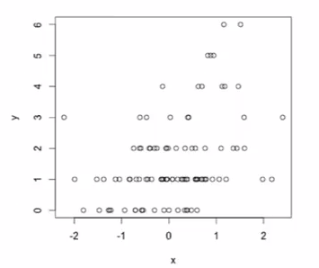

**Random Sampling**

1. Use the sample function to draw numbers randomly from a set of scalars in R.
   1. Example: **sample(1:10, 4)** gives 4 random variables from the vector 1-10
   2. Example: **sample(letters, 5)** gives 5 random letters from the alphabet
   3. Example: **sample(1:10)** gives all 10 numbers back in a random order
   4. Example: **sample(1:10, replace = TRUE)** gives back 10 numbers where the numbers may be repeated
   5. Note: set.seed will work on the sample function
2. Other standard distributions built into R:
   1. Normal
   2. Poisson
   3. Binomial
   4. Exponential
   5. Gamma